Supplementary Materials

Pervasive pairwise intragenic epistasis among sequential mutations in TEM-1 β-lactamase

Courtney E. Gonzalez and Marc Ostermeier

Department of Chemical and Biomolecular Engineering, Johns Hopkins University, 3400 N. Charles St., Baltimore, MD 21218 USA.

Supplementary Figs. S1-S5
Supplementary Data S1-S4

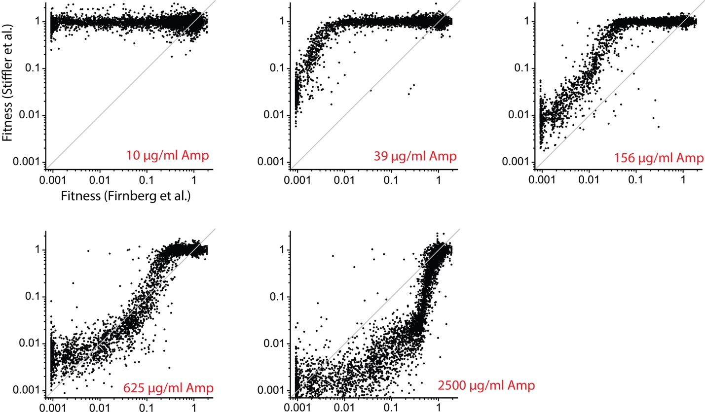

Supplementary Fig. S1. Fitness values for amino acid substitutions in TEM-1 measured by growth competition compared to fitness values measured by our bandpass MIC-like method [22]. Stiffler et al [23] performed the growth competition experiments in liquid LB media (with different concentrations of Amp as indicated) with DH10B E. coli cells containing TEM-1 under its native, constitutive promoter on plasmid pBR322. The fitness value associated with a mutation was measured by calculating the change in allele frequency relative to wildtype between before and after the growth competition. We performed our experiments on LB-agar plates with SNO301 E. coli cells containing TEM-1 under the IPTG-inducible tac promoter on a lower-copy p15A origin plasmid [22]. Fitness was measured as the resistance of cells carrying the mutation relative to wildtype using the bandpass system. This fitness measurement does not depend on the ampicillin concentration in the media (i.e. the fitness measurement for Firnberg et al is the same in all five graphs). The line is x=y.

Supplementary Fig. S2. (a) Experimental distribution of epistasis values obtained for pairs of amino acids in this study (b) Theoretical distribution of possible pairs of amino acids based on the genetic code.

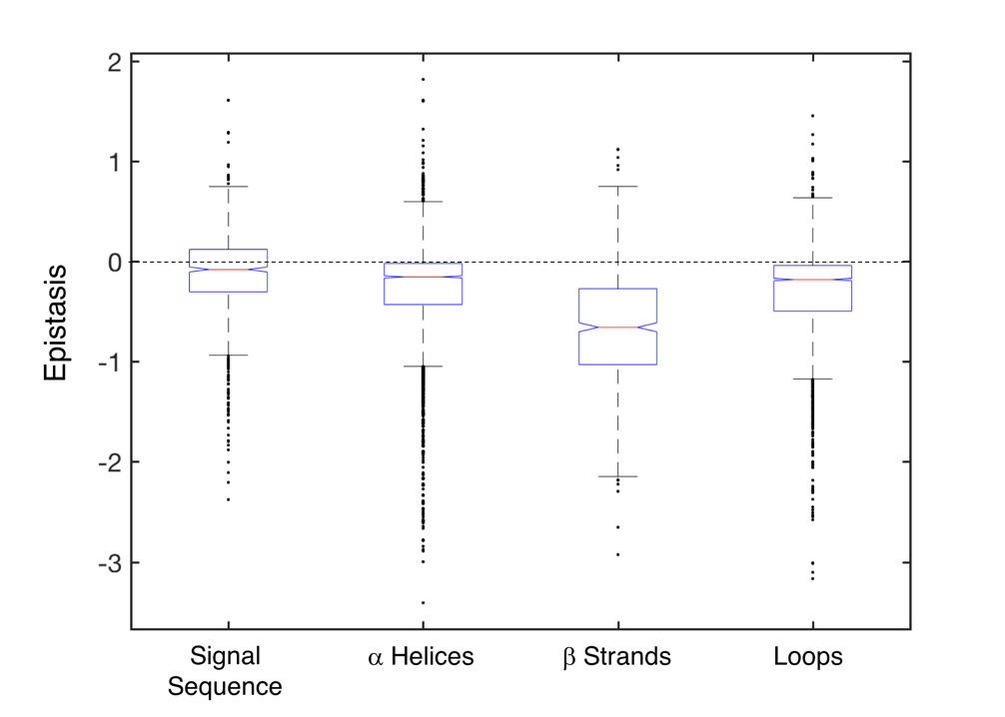
Supplementary Fig. S3. Epistasis values for the signal sequence and secondary structures. The central line indicates the median, and the bottom and top edges of the box indicate the 25th and 75th percentiles. The whiskers extend to the most extreme data points not considered outliers, which are represented by circles.

Supplementary Fig. S4. Median epistasis between pairs of mutant amino acids. The heat map indicates median epistasis values for mutant amino acid pairs that occurred throughout the protein. Median values are presented only for pairs with five or more epistasis values.

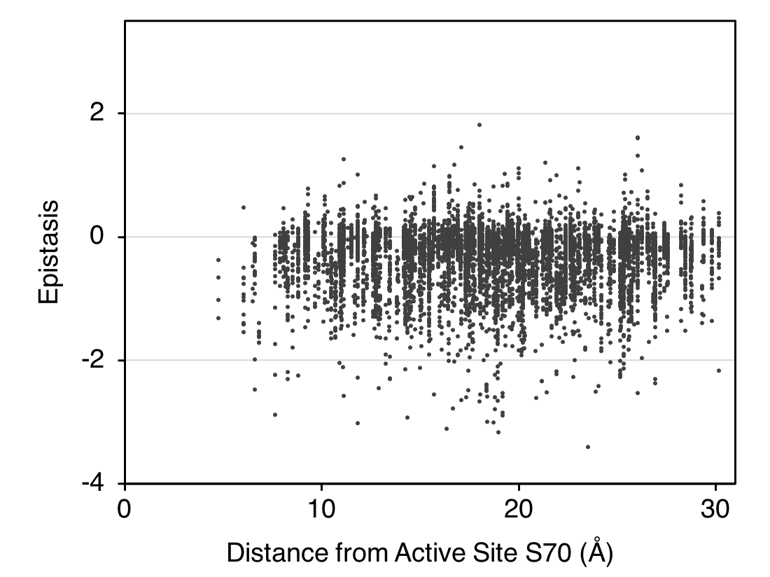
Supplementary Fig. S5. Epistasis as a function of distance from the active site S70. Distance was calculated from the first amino acid substituted.

